**Lab 8**

1. **a.** Create a procedure that when you run it with providing the employee ID, it will find the employee and will provide all the columns for that employee.

**a.1>>**

delimiter !!

create procedure Find_Employee(employee_ID int)

begin

select * from Employee where E_ID=employee_ID;

end !!

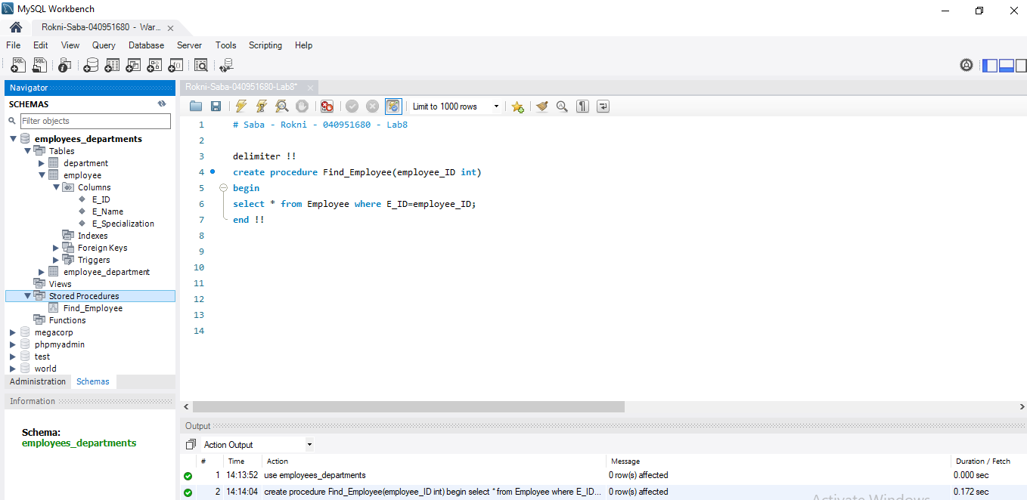

**a.2>>**

show all of employees inside of employee table

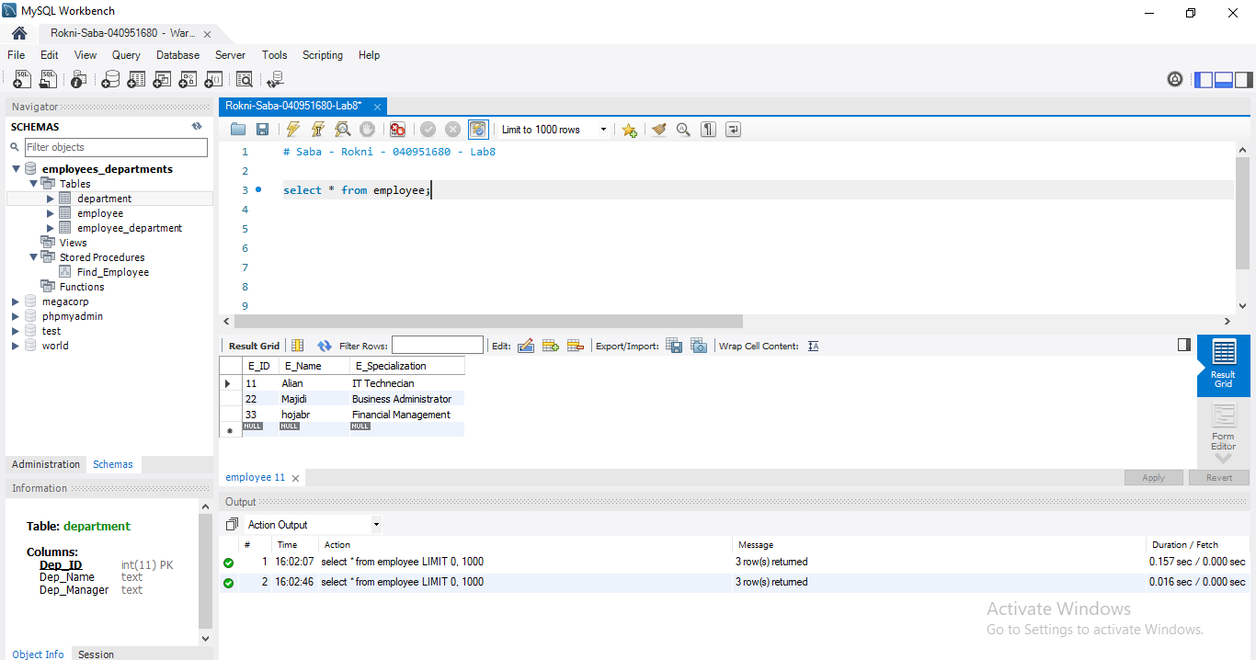

Call procedure:

call Find_Employee(22);

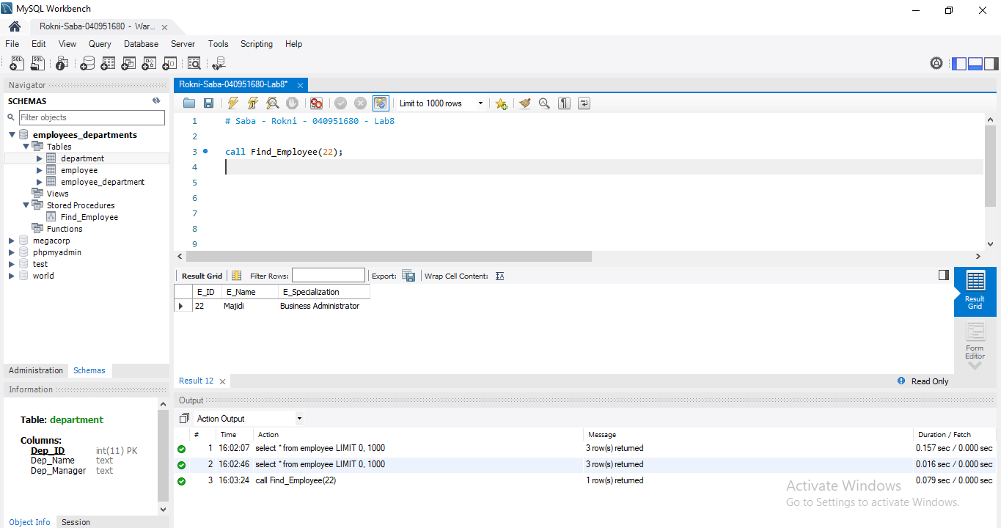

1. **b.** Create a function that when you apply apply it on the employee table (using select queries), it will provide for each employee the: “Employee Name” + is specialization in + “Specialization”. for example: “Anjariny is specialized in Business Intelligence”.

**b.1>>**

delimiter !!

create function Info_Employee(employee_name varchar(25),sentence varchar(50),employee_specialization varchar(25))

returns varchar(200)

deterministic

begin

return concat(employee_name,sentence,employee_specialization);

end !!

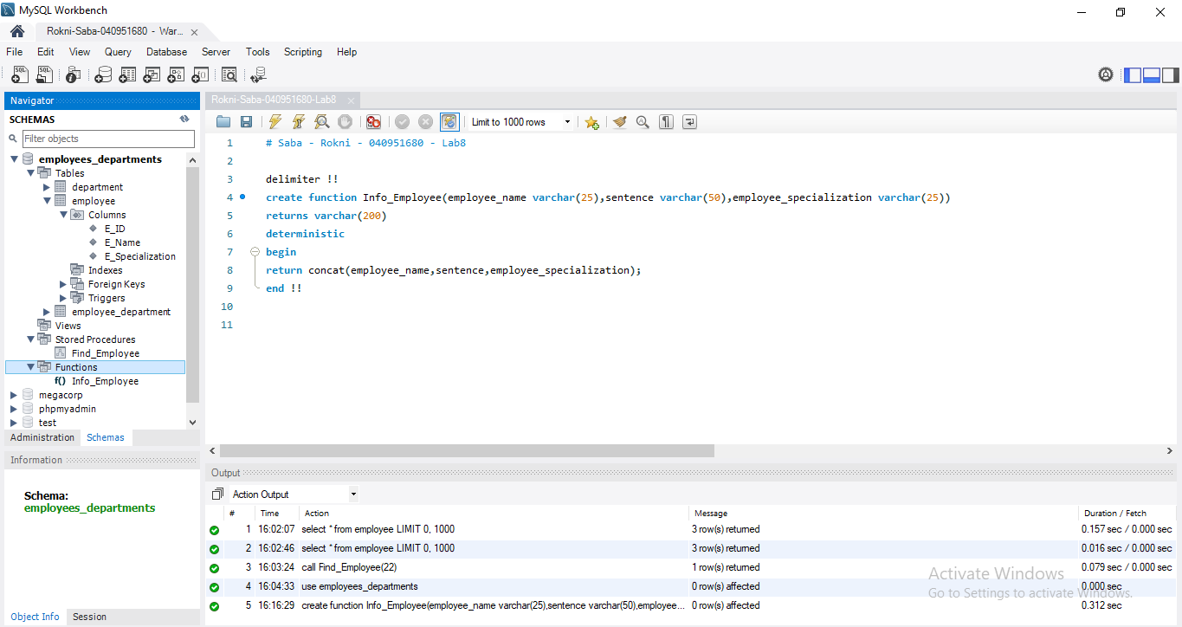

**b.2>>**

SELECT

INFO_EMPLOYEE (E_Name, ' is specialization in ', E_Specialization)

AS Employee_Information FROM employee;

